**ASSIGNMENT 4**

|  |  |
| --- | --- |
| Date | 6 nov 2022 |
| Team ID | PNT2022TMID26079 |
| Project Name | Gas Leakage Monitoring and Alerting System |
| Name | SAIRAJ M |

**Write code and connections in wokwi for ultrasonic sensor. Whenever distance is less than 100 cms send alert to ibm cloud and display in device recent events. Upload document with wokwi share link and images of ibmcloud.**

**CODE:**

#include <WiFi.h>

#include <PubSubClient.h>

WiFiClient wifiClient;

String data3;

#define ORG "9djwz2"//IBM ORGANITION ID

#define DEVICE_TYPE "sanjay"//Device type mentioned in ibm watson IOT Platform

#define DEVICE_ID "1234567"//Device ID mentioned in ibm watson IOT Platform

#define TOKEN "12345678"

#define speed 0.034

#define led 14

char server[] = ORG ".messaging.internetofthings.ibmcloud.com";

char publishTopic[] = "iot-2/evt/event_1/fmt/json";

char topic[] = "iot-2/cmd/led/fmt/String";

char authMethod[] = "use-token-auth";

char token[] = TOKEN;

char clientId[] = "d:" ORG ":" DEVICE_TYPE ":" DEVICE_ID;

PubSubClient client(server, 1883, wifiClient);

const int trigpin=5;

const int echopin=18;

String command;

String data="";

long duration;

float dist;

void setup()

{

Serial.begin(115200);

pinMode(led, OUTPUT);

pinMode(trigpin, OUTPUT);

pinMode(echopin, INPUT);

wifiConnect();

mqttConnect();

}

void loop() {

bool isNearby = dist < 100;

digitalWrite(led, isNearby);

publishData();

delay(500);

if (!client.loop()) {

mqttConnect();

}

}

void wifiConnect() {

Serial.print("Connecting to "); Serial.print("Wifi");

WiFi.begin("Wokwi-GUEST", "", 6);

while (WiFi.status() != WL_CONNECTED) {

delay(500);

Serial.print(".");

}

Serial.print("WiFi connected, IP address: "); Serial.println(WiFi.localIP());

}

void mqttConnect() {

if (!client.connected()) {

Serial.print("Reconnecting MQTT client to "); Serial.println(server);

while (!client.connect(clientId, authMethod, token)) {

Serial.print(".");

delay(500);

}

initManagedDevice();

Serial.println();

}

}

void initManagedDevice() {

if (client.subscribe(topic)) {

// Serial.println(client.subscribe(topic));

Serial.println("IBM subscribe to cmd OK");

} else {

Serial.println("subscribe to cmd FAILED");

}

}

void publishData()

{

digitalWrite(trigpin,LOW);

digitalWrite(trigpin,HIGH);

delayMicroseconds(10);

digitalWrite(trigpin,LOW);

duration=pulseIn(echopin,HIGH);

dist=duration*speed/2;

if(dist<100){

String payload = "{\"Alert Distance\":";

payload += dist;

payload += "}";

Serial.print("\n");

Serial.print("Sending payload: ");

Serial.println(payload);

if (client.publish(publishTopic, (char*) payload.c_str())) {

Serial.println("Publish OK");

}

}

if(dist>100){

String payload = "{\"Distance\":";

payload += dist;

payload += "}";

Serial.print("\n");

Serial.print("Sending payload: ");

Serial.println(payload);

if(client.publish(publishTopic, (char*) payload.c_str())) {

Serial.println("Publish OK");

}else {

Serial.println("Publish FAILED");

}

}

}

**Wokwi link:**

https://wokwi.com/projects/347956062652990036

**output:**

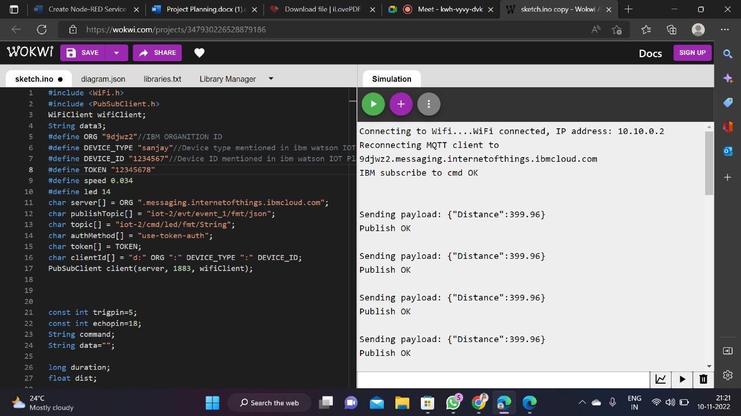

**WOKWI:**

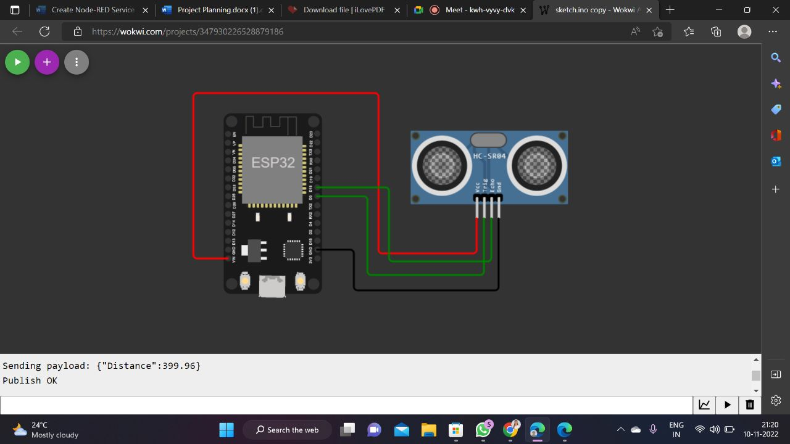

**IBM CLOUD:**

